Data Analytics Track – Stage 2B Task: Outlier Detection in Election Data Using Geospatial Analysis

Methodology.

The steps I took to carry out the geospatial analysis are as follows:

- The first step was to find the geolocations of each polling units in the various wards.

- The second step I took was to calculate the distance between polling units that are within a

radius of 2Km,this I did to determine neighbouring polling units.

- The next thing was to calculate the outlier scores for every party in order to know the political parties with the highest outlier score.

Spatial Distribution Overview (Benue Polling Units)

The datasets contain 4,046 polling units across Benue State, each with latitude and longitude coordinates. Using these coordinates, I calculated spatial proximity that is, how close polling units are to one another within a 2 km radius.

Neighbourhood Structure
- Out of the 4,046 polling units, 3,804 units (94%) have at least one neighbouring unit within 2 km.
- 242 units (6%) do not have any neighbours within this distance meaning they are spatially isolated
Spatial Integrity: The dataset shows strong spatial structure suitable for neighbourhood analysis, regional clustering, or logistics optimization (e.g., election material distribution or voter access analysis

Note on Empty Rows During Sorting:
When sorting outlier scores in Google Sheets, rows with empty cells in the sorted columns moved to the bottom of the dataset. This is normal behavior and does not delete any data. For analysis, only rows with valid outlier scores were used, ensuring that all calculations and rankings are based on complete data.
the top 3 outliers scores
The table of outlier scores for the top three polling units shows the degree to which votes for each party deviate from their neighboring units:
APC_Outlier | LP_Outlier | PDP_Outlier | NNPP_Outlier
54.92 | 71.17 | 80.67 | 80.08
13.29 | 49.00 | 32.14 | 62.86
4.58 | 48.76 | 7.61 | 56.15
Explanation:
- High deviation indicates unusual voting patterns: For example, in the first polling unit, PDP and NNPP have outlier scores above 80, meaning their vote counts are substantially higher or lower than neighboring polling units, signaling potential irregularities.
- APC and LP also show significant deviations (54.92 and 71.17), reinforcing the idea that this unit’s voting pattern is not consistent with its neighbors.
- Second and third units: These units also show elevated deviations for specific parties (e.g., NNPP 62.86 and 56.15), though lower than the first.
The differences highlight localized irregularities rather than statewide trends, making these units important for further review.
- Overall insight: Outlier scores provide a quantitative measure of voting irregularities, enabling analysts to focus investigations on the polling units where results differ most from nearby units. The data Visualization can be seen below

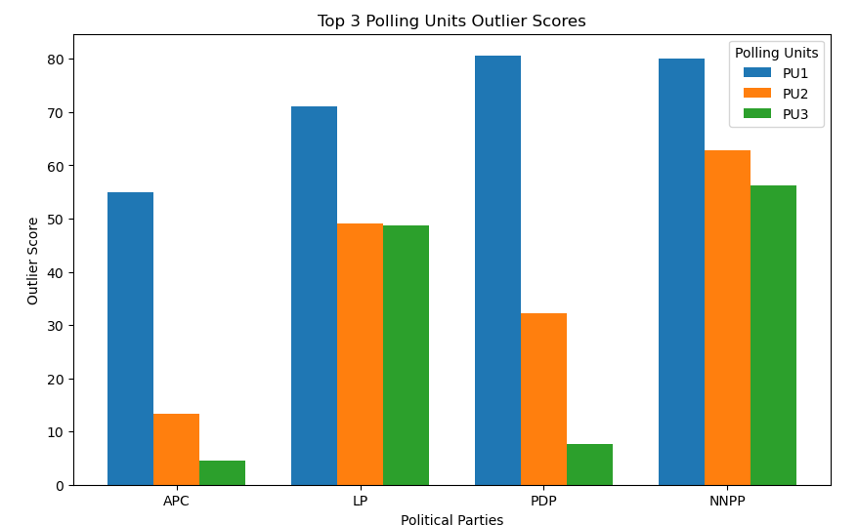
The top 3 units represent the most significant deviations in Benue State, across all four major parties.

Conclusion
The geospatial analysis identified polling units in Benue State with voting patterns that significantly deviated from their neighbors. Top outlier scores highlight units where vote counts for APC, LP, PDP, and NNPP differ most from surrounding areas, indicating potential irregularities. Overall, most polling units showed spatial consistency, while deviations were localized. This method provides a clear, quantitative approach to detect unusual voting patterns and support election integrity.

